**Challenge 2 – Esports Tour**

**The top eSports competitors from across the globe have gathered to battle it out. Can you analyse the following data to find out all about the tournament?**

**Jermaine Sangiwa**

# **QUESTION 1: WHAT ARE THE NAMES OF THE PLAYERS WHOSE SALARY IS GREATER THAN 100,000?**

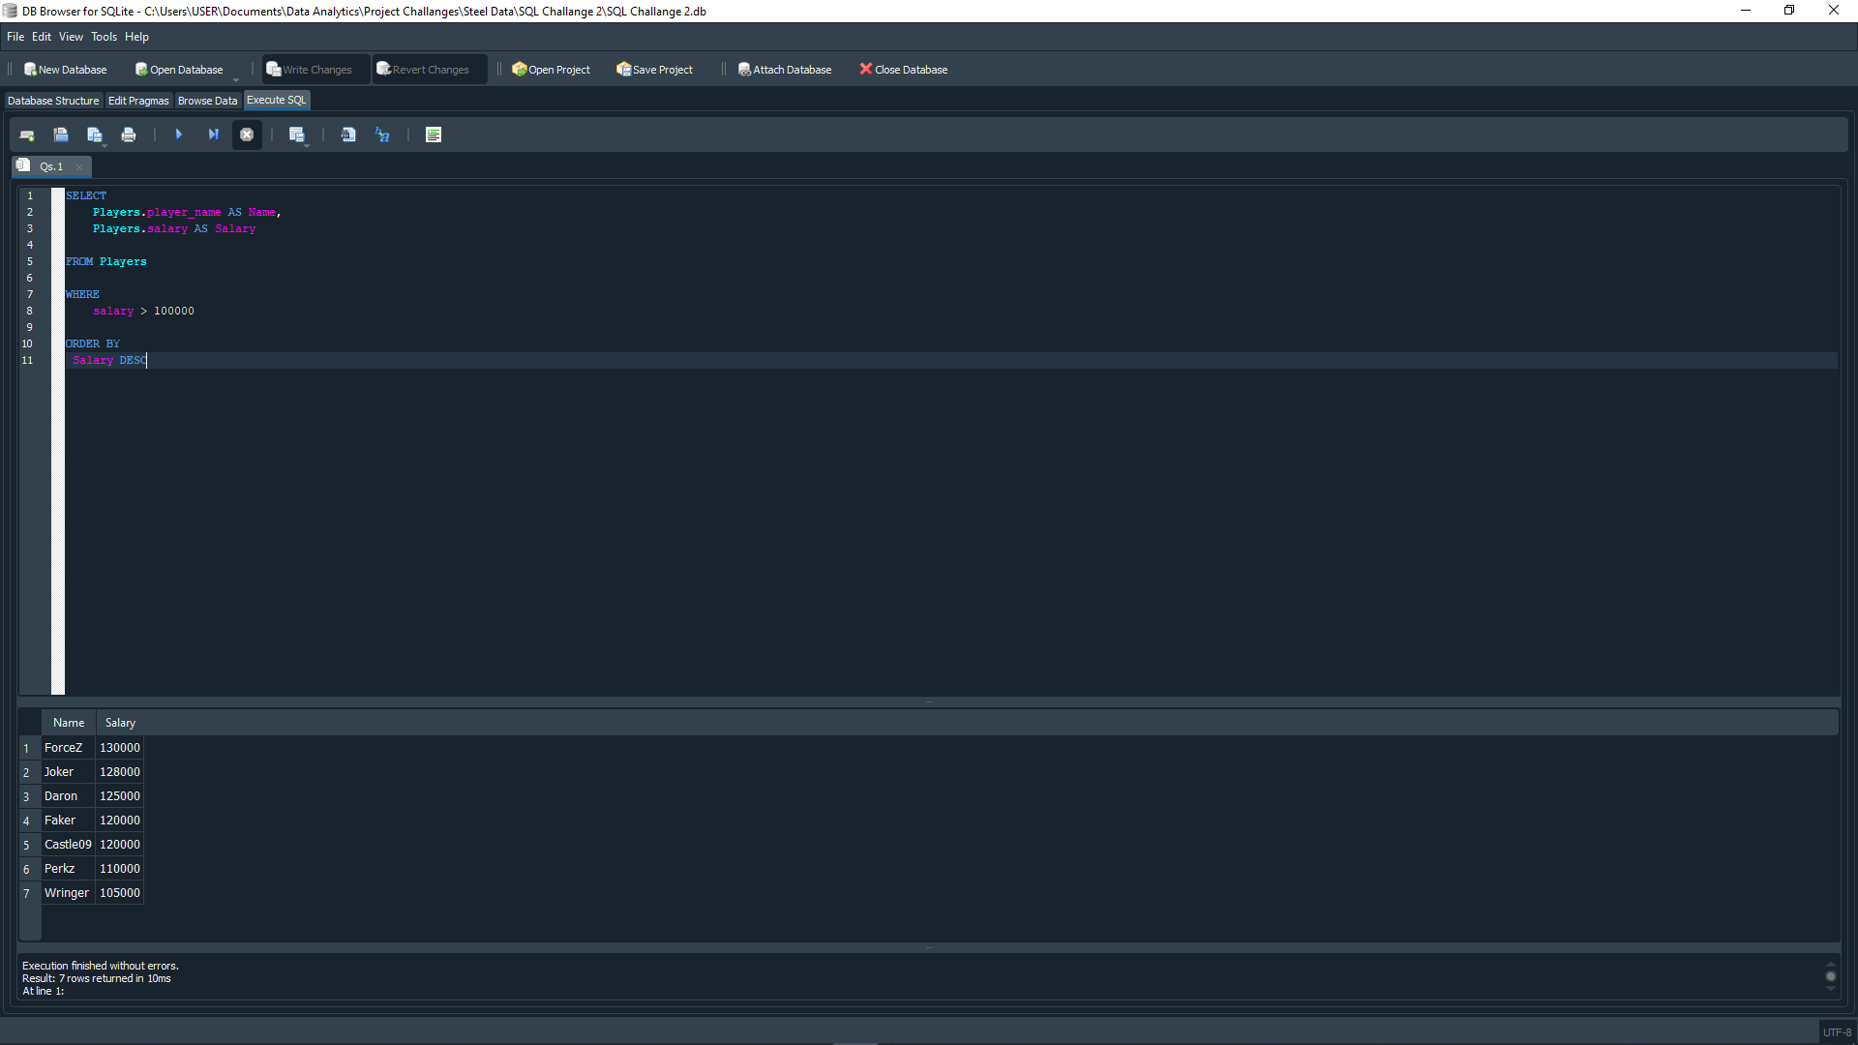

There are seven players whose salary is greater than $100,000. Those players are:

1. “ForceZ”: $130,000
2. “Joker”: $128,000
3. “Daron”: $125,000
4. “Faker”: $120,000
5. “Castle09”: $120,000
6. “Perkz”: $110,000
7. “Wringer”: $105,000

# **QUESTION 2: WHAT IS THE TEAM’S NAME OF THE PLAYER WITH player_id = 3?**

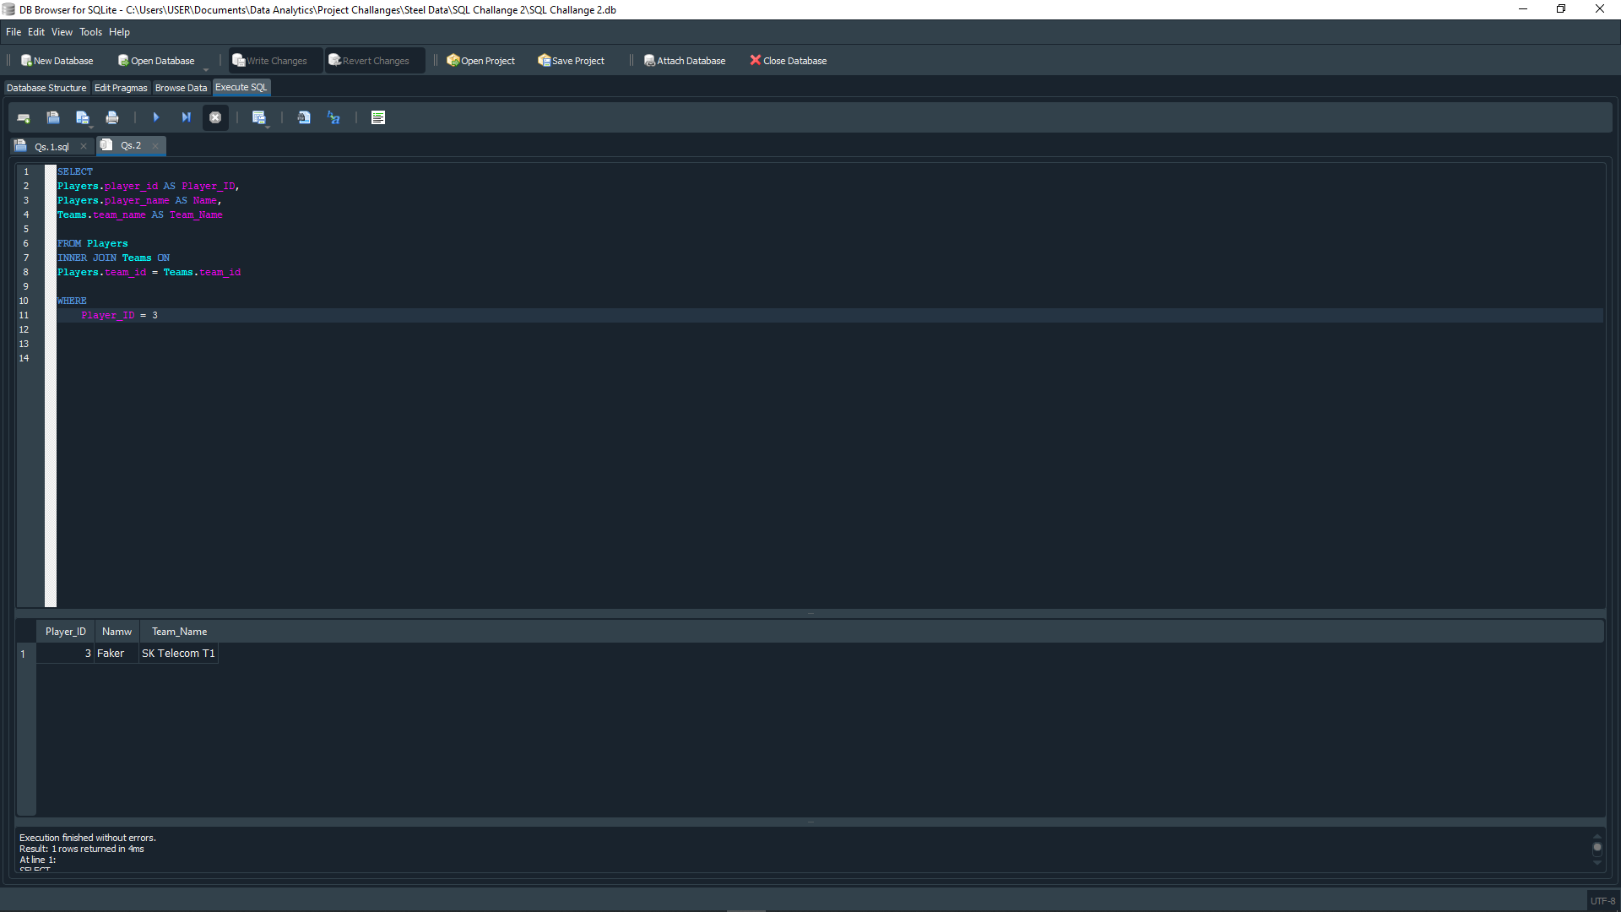

The team’s name of the player with player_id = 3 (Faker) is “SK Telecom T1”

# **QUESTION 3: WHAT IS THE TOTAL NUMBER OF PLAYERS IN EACH TEAM?**

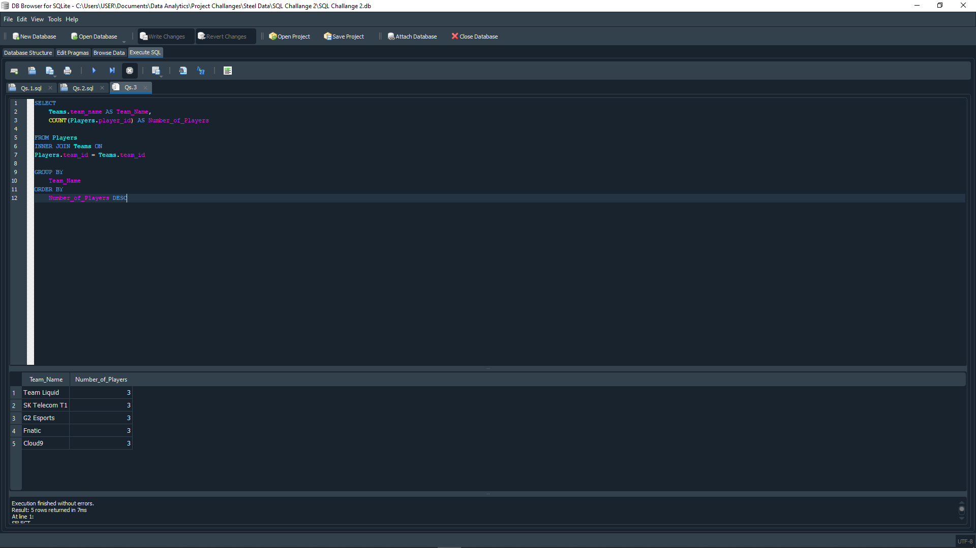

The total number of players in each team are:

1. Team Liquid: 3
2. SK Telecom T1: 3
3. G2 Esports: 3
4. Fnatic: 3
5. Cloud9: 3

# **QUESTION 4: WHAT IS THE TEAM’S NAME AND CAPTAIN NAME OF THE TEAM WITH “team_id” = 2?**

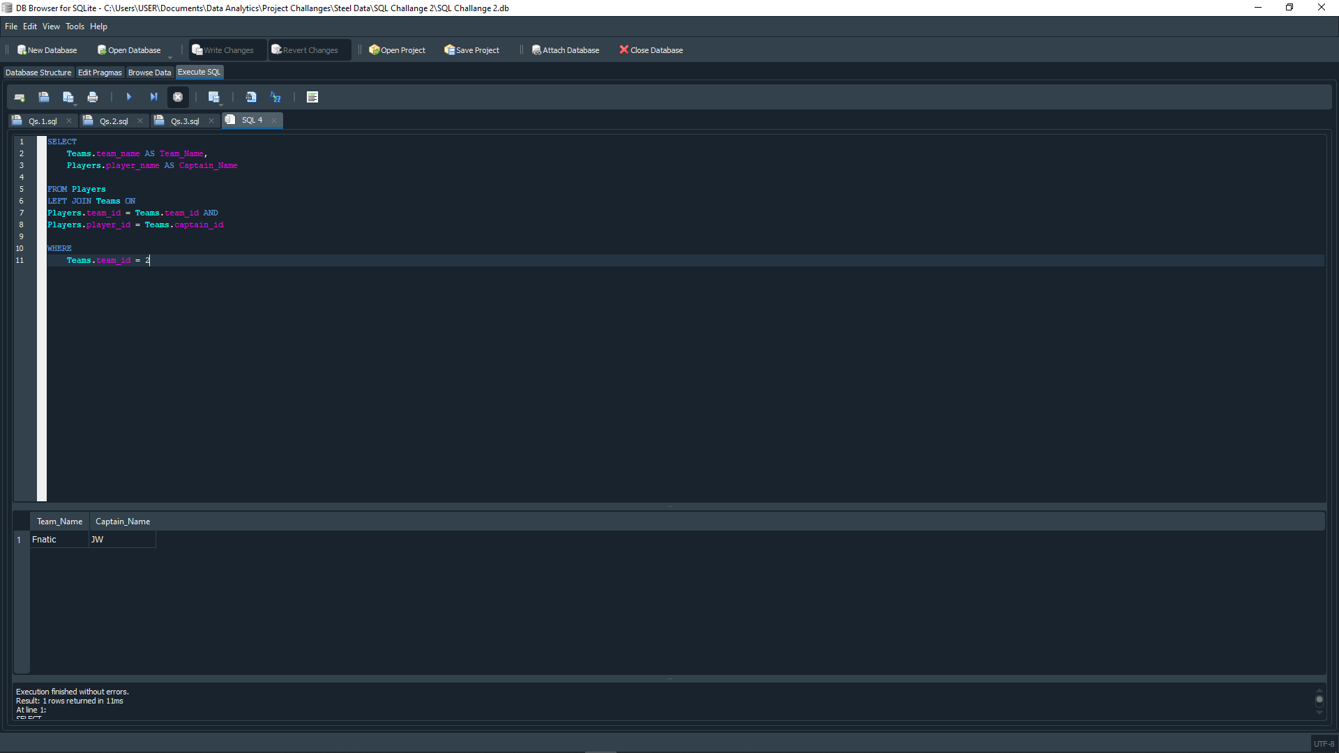

The team’s name and captain name of the team with ID number = 2 is:

* “Fnatic”, the team’s captain name is JW.

# **QUESTION 5: WHAT ARE THE PLAYER NAMES AND THEIR ROLES IN THE TEAM WITH “team_id” = 1?**

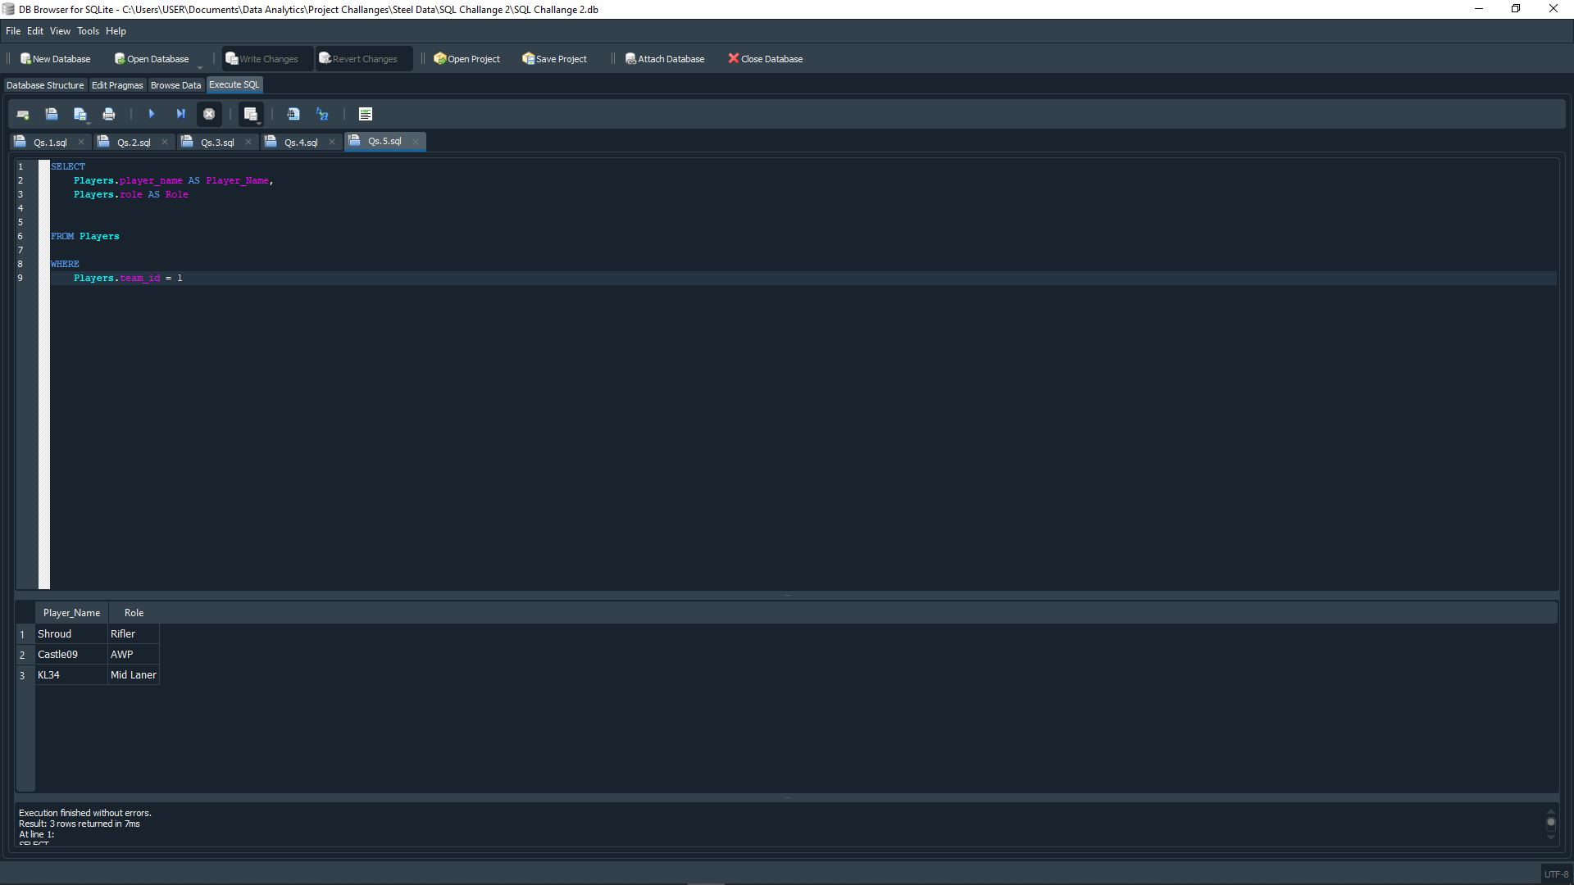

The player names and their roles in the team with team_id = 1 (Cloud9) are:

1. Player Name: “Shroud”, Role: “Rifler”
2. Player Name: “Castle09”, Role: “AWP”
3. Player Name: “KL34”, Role: “Mid Laner”

# **QUESTION 6: WHAT ARE THE TEAM NAMES AND THE NUMBER OF MATCHES THEY HAVE WON?**

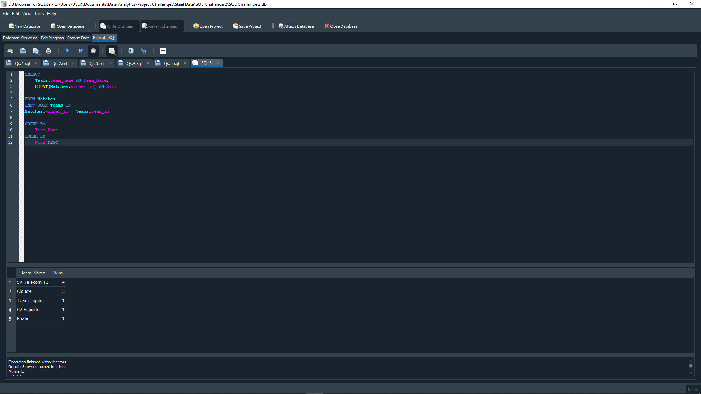

The number of matches each teams won are:

1. SK Telecom T1: 4
2. Cloud9: 3
3. Team Liquid: 1
4. G2 Esports: 1
5. Fnatic: 1

# **QUESTION 7: WHAT IS THE AVERAGE SALARY OF PLAYERS IN THE TEAMS WITH COUNTRY ‘USA’?**

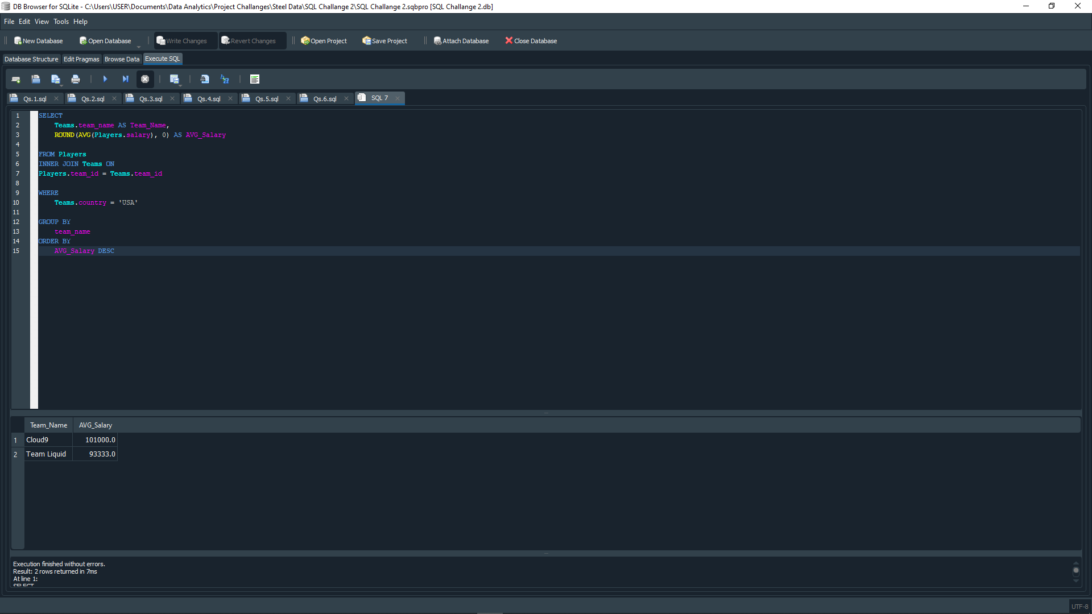

The average salary of players in the Teams with country USA are:

1. Cloud9, average salary is $101,000
2. Team Liquid, average salary is $93,333

# **QUESTION 8: WHICH TEAM WON THE MOST MATCHES?**

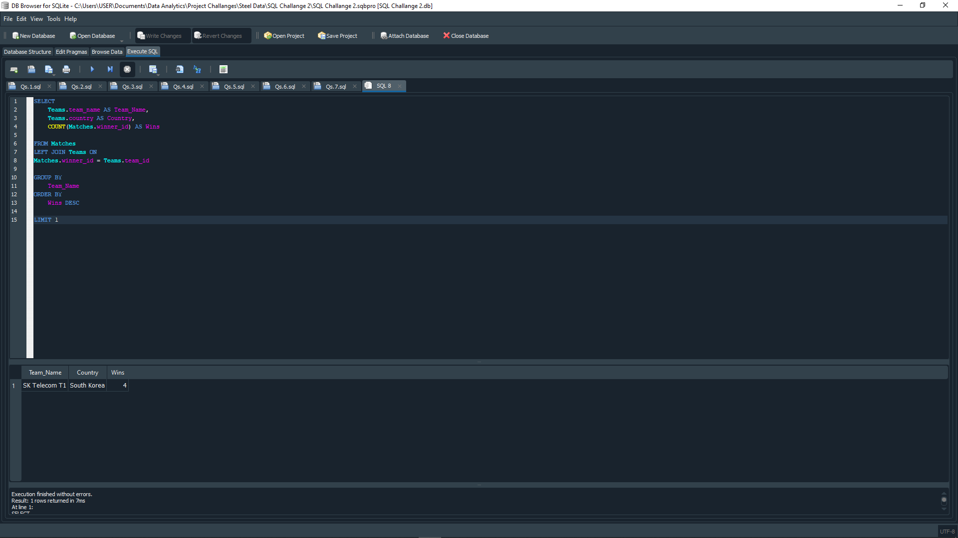

The team with the most match wins is “SK Telecom T1” from South Korea. They have a total of 4 wins.

# **QUESTION 9: WHAT ARE THE TEAM NAMES AND THE NUMBER OF PLAYERS IN EACH TEAM WHOSE SALARY IS GREATER THAN 100,000?**

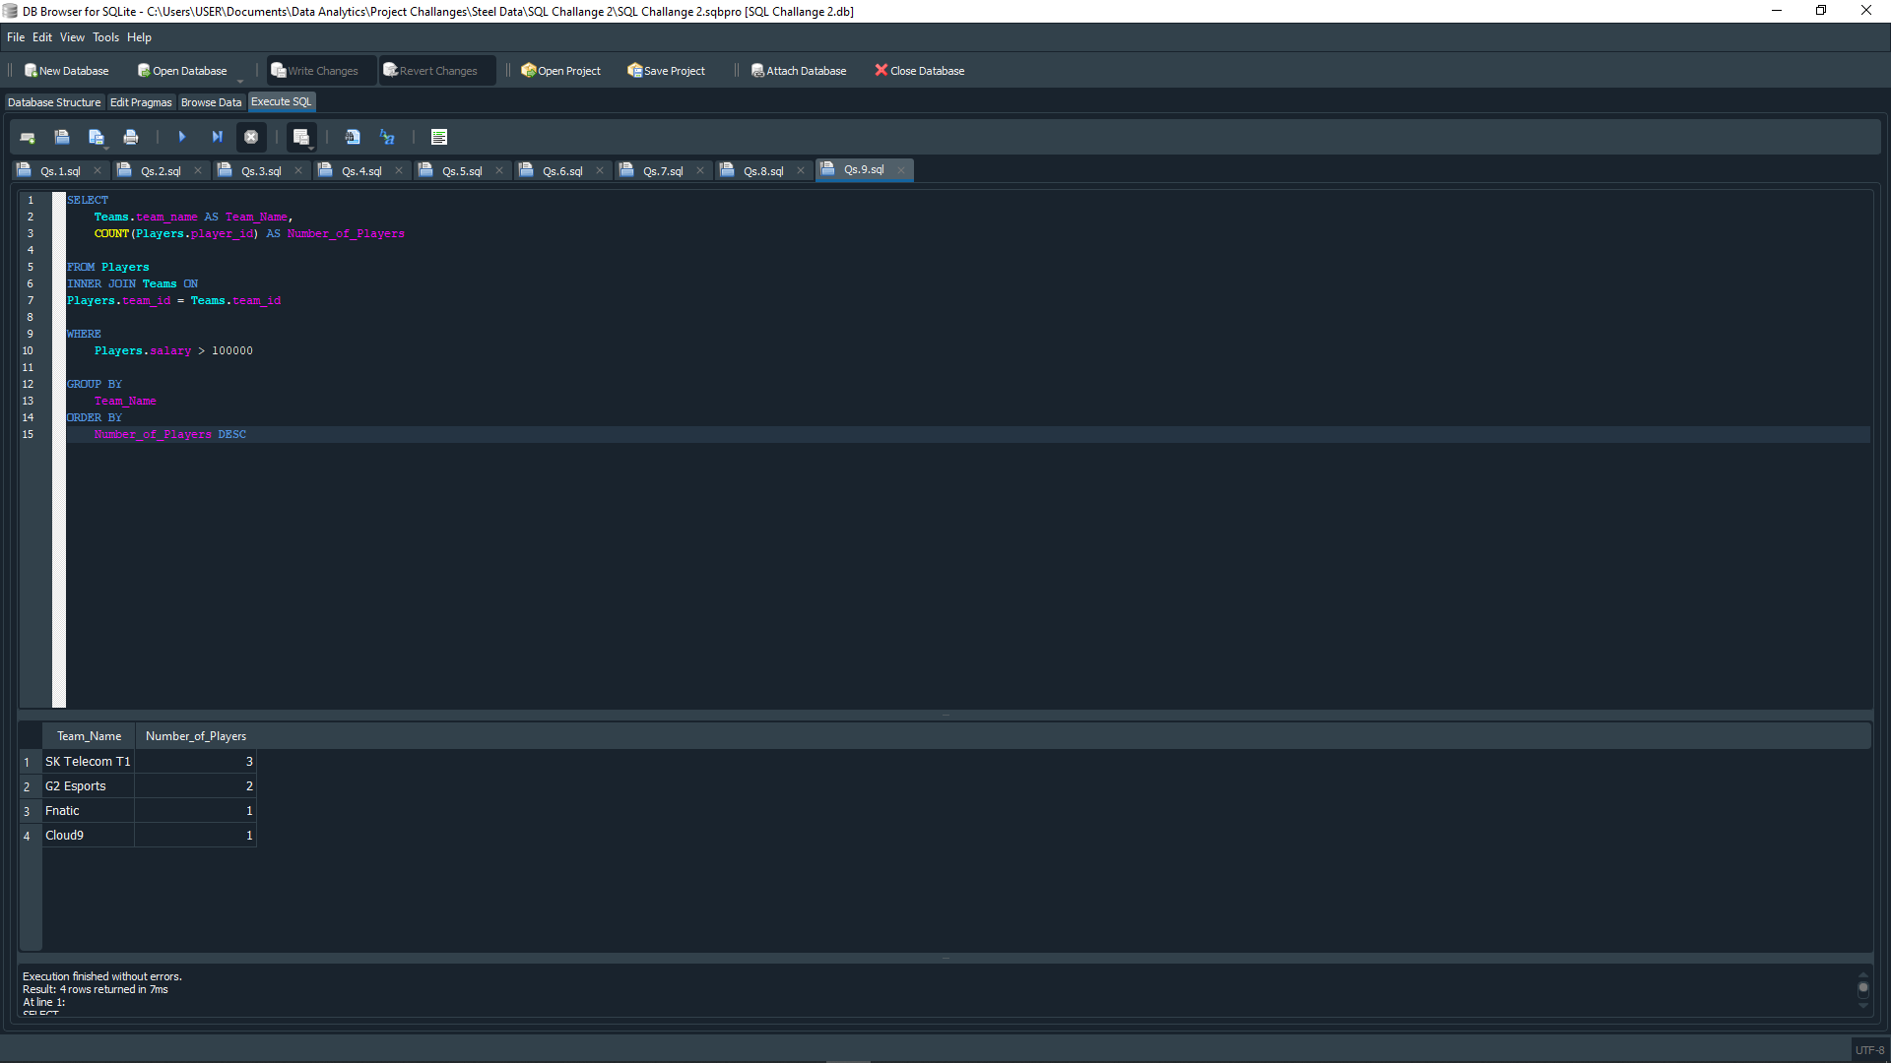

The number of players in each team whose salary is greater than $100,000 are:

1. SK Telecom T1: 3
2. G2 Esports: 2
3. Fnatic: 1
4. Cloud9: 1

# **QUESTION 10: WHAT IS THE DATE AND THE SCORE OF THE MATCH WITH “match_id” = 3?**

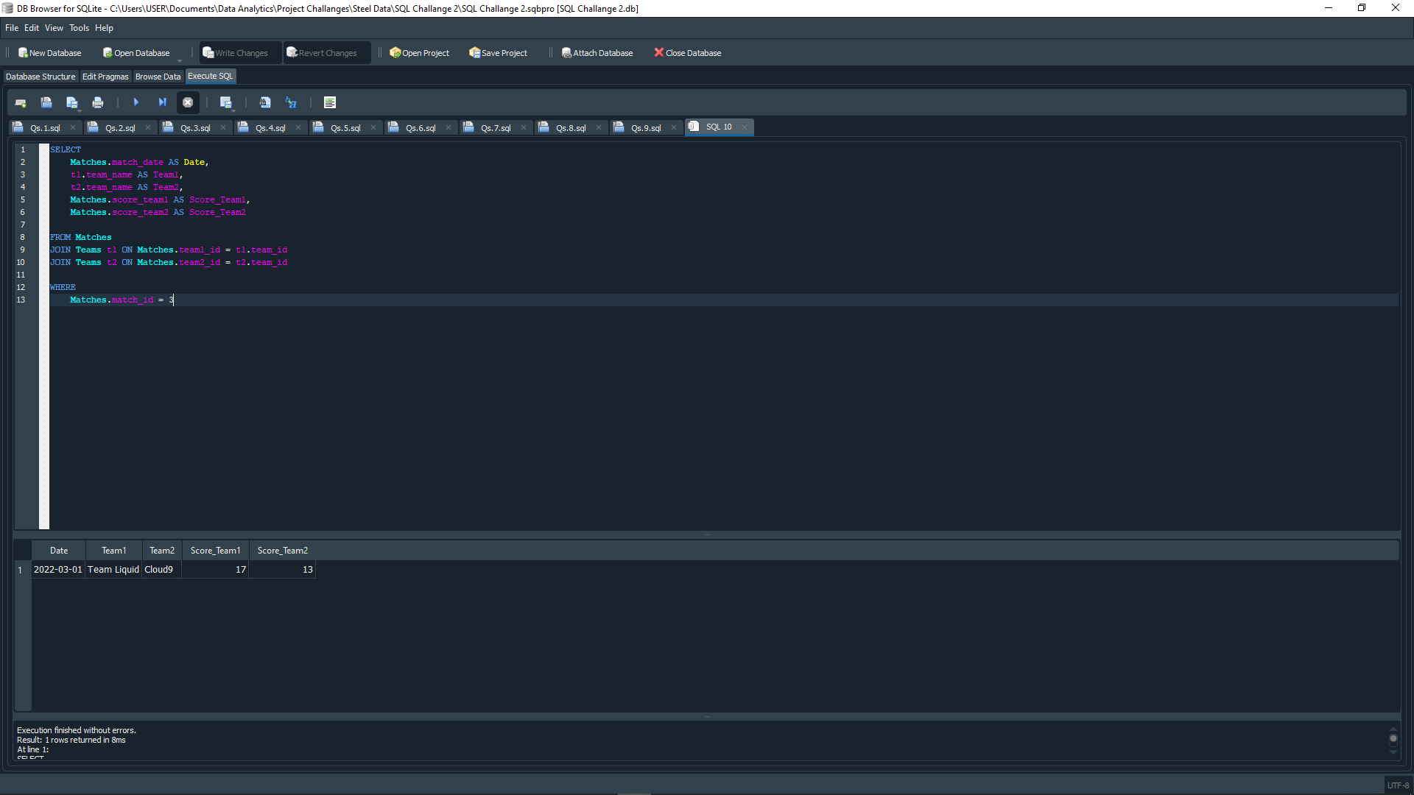

The match in “match id” = 3, was between “Team Liquid” vs “Cloud9”. The match held on 1st March, 2022 and the score of the match was 17 for “Team Liquid” and 13 for “Cloud9”.